|  |  |  |  |
| --- | --- | --- | --- |
| Name:  Teacher : | ____________________________________  ______________________ | | Date:_________ |
|  | **Year 12 Essentials**  /  **Time**  **Full working out MUST be shown to get full marks for each question.** | | |
| **Total Time:** | 30 minutes |  | |
| **Weighting:** | 5% |
| **Equipment:** | Pen, pencil, ruler, scientific calculator. | | |

Q1) Match the correct shape to its net: [ 5 marks]

|  |  |
| --- | --- |
| 1 | A |
| 2 | B |
| 3 | C |
| 4 | D |
| 5 | E |

Q2) Define the following terms: [ 3 marks]

1. A Vertex is a _____________________________
2. A Face is a _______________________________
3. An Edge is a ____________________________________

Q3) Complete the following table [4 Marks]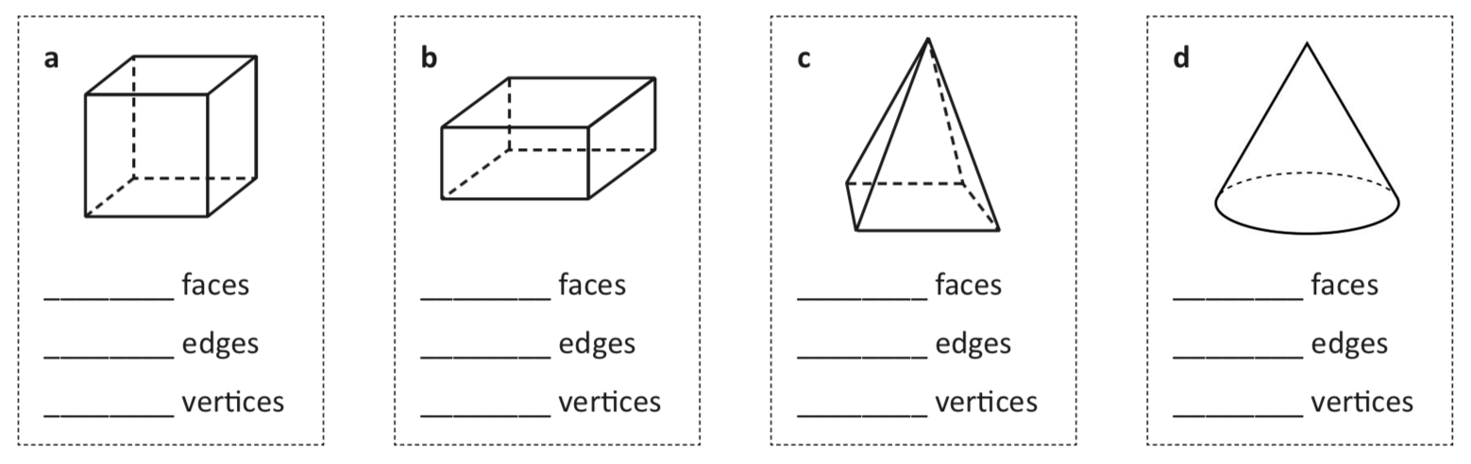

Q4) Eulers formula states that for all 3-D shapes, when adding the faces to the Vertices, then subtracting the edges you will always receive an answer of 2. [3 Marks]

1. Does this formula hold true for the shapes above?
2. Is there a common 3-d shape above that this rule does not work for? Why?

Q5) Using the following shape, Draw the front, right and top views of this shape:

|  |  |  |  |
| --- | --- | --- | --- |
| Isometric drawing | Front view | Right view | Top view |
|  |  |  |  |

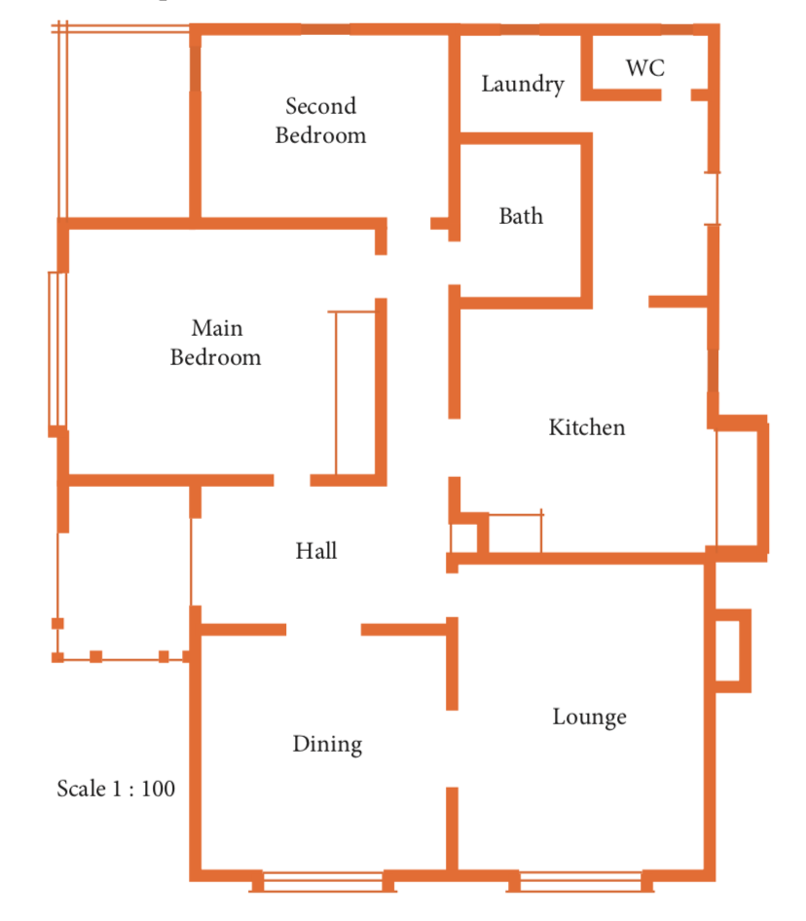Q6) The houseplan below is draw to a scale of 1:100. Use this information to answer the following. [14 mark]

1. The length of the dining room is 4.5cm by 4.5cm. How long would this be in real life?
2. The house will have tiles in the Laundry, Toilet, Kitchen and Bathroom. This is a rectangle that is 9.5cm by 4.5cm on the plan. How big is this area in the real world?
3. If 1 pack of tiles cost $80 per square meter, how much would it cost to tile this area?
4. The loungroom has an area of 24.75m2. What is this in square cm?
5. The main bedroom is 5.5cm by 4.5cm, and the second bedroom is 3.5cm by 4.5.cm. They choose to use carpet tiles 800mm x 800mm. They come in a pack of 15. How many packs would they need to purchase to cover both rooms?

END OF ASSESSMENT